Calling All Rochester Parents!
We began a process late last year to determine core values in our school community. We continued this school year with the process and over the course of the last several months we met with students in every class and engaged in discussions with all staff to hear their views about what attributes contribute to a healthy school culture.
Now we need to hear from you!
Your responses, anonymous or not, (point form words and phrases) to any or all of the thought starters detailed below is kindly requested. They are no “correct answers” here. Either jot down your responses on the attached response page and return to our office or email our Parent Representatives on the SPC (School Planning Council) at: rochester.elementary@yahoo.ca with your responses. Put the word, “Values” in your subject line please.
Regards and thank you in advance for your time and consideration,

John Goheen
Principal

Please respond to any of the following:

- How do you want our students to treat each other?
- How do you want adults to treat each other?
- What would you see people doing at Rochester if everyone were being the best version of themselves?
- What kind of things would you hear students/staff/parents saying to each other?
- What kind of information or values do we want to communicate by our choices and actions?
- What kind of behaviours do you want to see as the “normal way” people are in relation with one another here?

We asked your children similar age level appropriate versions of these questions and all ages and all grades responded with meaningful and thoughtful ideas. Some common themes began to emerge regardless of age. Working with our parent SPC (School Planning Council), we will look at all the input from you, your kids, and staff and then look for common and reoccurring themes. These will help form our core values, perhaps three to five that will help us move forward to build the school culture we all want to see.

While this process takes time, it is critical that all those who are part of the community know that our core values, once determined, belong to all of us. Of course once identified, all members of our community are then expected to live these values. These values will become the measure by which we will evaluate interactions at school.

In advance, we thank you for taking the time to respond to this important request.

This WORDLE represents value attributes expressed in every classroom at Rochester. There were many more ideas but these were common throughout. These are the behaviours that your children want to see characterize how students, parents and teachers are “in relation” in our community.

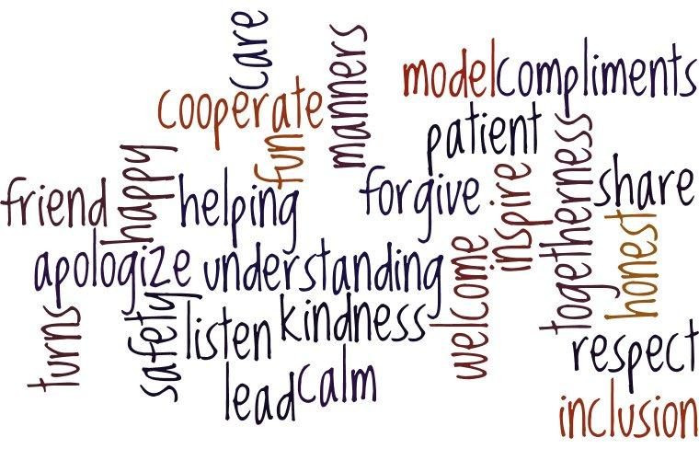

Soon we can add your thoughts and those of our teachers’ to this Wordle

rochester.elementary@yahoo.ca
Rochester Values Response Page
Your name ___________________________________________________________________
Contact info (in case we have a clarifying question) ___________________________________________________________________
